**EE533 Network Processor Design & Programming**

**Lab #3: Mini Intrusion Detection System (mini-IDS)**

Instructor: Prof. Young Cho, PhD

***Name: Archit Sethi***

***University of Southern California***

***Los Angeles, CA 90007***

GITHUB LINK to my REPOSITORY

Aarch0811/EE533/LAB3/

Archit’s GITHUB: [LINK](https://github.com/Aarch0811/EE533/tree/main/LAB3)

1. Take a look at the created Verilog. Do they make sense? Which do you think easier: entering the schematics or writing Verilog? Why? In which cases might you do the other?

*A.1. The script that I had generated appears unintelligible because the tool assigns highly specific instance names, wire names, and module names. Although the simulation functions correctly, interpreting the generated code is quite challenging.*

*Personally, writing RTL logic for a large circuit like this would be far more manageable since the code can be modular and reused efficiently. High-level behavioural modelling in HDL significantly reduces the effort required for logic design compared to schematic-based implementation. Additionally, debugging is much more straightforward if any issues arise.*

1. Download the Lab5_mini_ids_src.zip file.
   1. In this file you will find two directories.
   2. Extract ids_sim directory to your ISE project. You should now be able to simulate the mini-IDS using the ids_tb.tbw testbench. The other files are needed to emulate the pieces of the NetFPGA that are around your design. Run the testbench and take a screenshot. Describe what the testbench does and how it shows that the mini-IDS is functioning.

*Ans: For a mini-intrusion detection (mini-IDS) system, three key components are required: an input data stream, a pattern matching logic to identify specific intrusion patterns, and an output FIFO wrapper that discards detected intrusive packets while transferring the remaining data to a dual-port FIFO. This FIFO serves to isolate intrusion-free packets from the subsequent processing stages.*

*The testbench consists of four main components:*

Detect7B Matcher: *This module identifies intrusive data bit patterns within the input stream received from the fall-through FIFO.*

Fallthrough fifo: *This acts as a buffer for feeding packets into the pattern detection logic. It functions as a decoupler, isolating the input data stream from the pattern matching mechanism.*

Dropfifo: *A First-In-First-Out (FIFO) designed to eliminate packets that contain identified intrusion patterns while passing the rest of the data through.*

Packet Separation Logic: *A state machine responsible for extracting the header and payload from incoming packets. This enables a byte-by-byte comparison of the payload against predefined intrusion patterns for detection.*

1. Write and submit your lab report.
   1. Explain the pattern matching algorithm in the report.

*Intrusion Detection System Overview: The concept of this intrusion detection system is to identify 7-byte malicious patterns within an incoming network data stream. The system processes 9-byte packets, consisting of 8 bytes of data and 1 byte for control signals. These packets pass through a fall-through FIFO before being analysed by the 7B pattern-matcher module. Since malicious patterns can be dispersed across multiple packets in various ways, all potential edge cases must be considered.*

*Consider a scenario where only 1 byte of the malicious sequence appears at the end of one packet, while the remaining 6 bytes continue into the next packet, must be addressed.*

*In addition, other combinations, such as 3 bytes in one packet and 4 bytes in the next, must be handled to ensure comprehensive detection. Addressing the worst-case scenario allows the system to be robust against fragmented malicious patterns.*

*System Components and Functionality: To construct a mini-IDS system, the following components are necessary:*

Detect7B Matcher: *This module is responsible for scanning the incoming data stream to identify occurrences of the malicious 7-byte pattern. It takes input from the fall-through FIFO and performs pattern detection.*

Fall-through fifo: *This FIFO serves as a buffer for feeding packets into the pattern detection logic. It acts as a decoupler, isolating the input data stream from the pattern matching process to prevent interference.*

Packet Separation Logic: *This module functions as a state machine, responsible for extracting headers and payloads from incoming packets. It enables byte-by-byte comparison of packet content with predefined intrusion patterns*

Dropfifo: *This FIFO is designed to eliminate packets that contain detected malicious patterns. Only packets that do not match the intrusion pattern are forwarded for further processing.*

Please find attached the figures of Schematics for comparator, Detect7B, wordmatch, dropfifo as follows:

Comparator:

Detect7B:

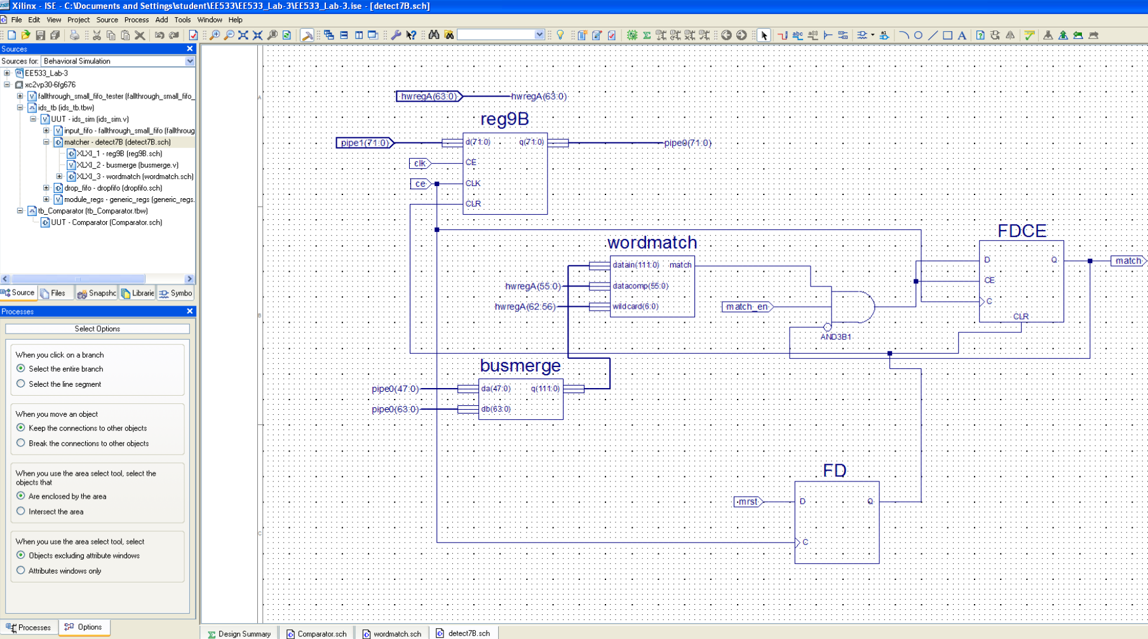

Wordmatch:

Dropfifo:

* 1. Include the answers to your lab in this report.
     1. What is the purpose of AMASK[6:0]?

*Ans: The AMASK[6:0] register determines which bytes of the predefined pattern are compared against the incoming data stream. When we set to 7’b1111111, all 7 bytes are actively matched against the corresponding bytes in the input packet.*

*However, if any bit is cleared (it is set to 0), the respective byte is ignored in the comparison and treated as a don’t care value. This selective matching approach enhances flexibility, allowing the system to adaptively compare relevant bytes rather than rigidly enforcing a full-pattern match in all scenarios.*

* + 1. What exactly does busmerge.v do?

*Ans: To perform a continuous* ***7-byte comparison****, we require two overlapping* ***7-byte segments*** *of input data. This ensures that if part of a pattern appears at the end of one chunk and the remaining portion appears in the next, it can still be detected.*

*The* ***busmerge.v*** *facilitates this by* ***concatenating 6 bytes from the previous data chunk*** *with the* ***8 bytes of newly received data*** *(effectively merging data from consecutive clock cycles). This combined data stream is then passed to the pattern matching logic for comparison.*

* + 1. What do the comp8 modules do in this schematic?

*Ans: The comparator is responsible for analysing each byte of the incoming data packet and determining whether it matches the reference data byte from the pattern stream. It outputs a signal indicating whether there is a match or equality between the two.*

* + 1. What is the purpose of dual19Bem in dropfifo.sch?

*Ans: The dual-port* ***9-byte memory*** *is designed to filter out pattern-matched malicious data, ensuring that only non-malicious data is stored. It consists of* ***8 bytes of data*** *along with* ***1 byte of control signals****, making a total of* ***9 bytes****. This FIFO, which exclusively admits verified safe data, serves as a buffer that effectively* ***isolates the processed data from the consuming system****.*

* 1. Please also include all of the screen capture as well as generated Verilog.
     1. Generated Waveform:

* + 1. Detect7b generated Verilog: A screenshot of a computer

       Description automatically generated
    2. Comparator generated Verilog:

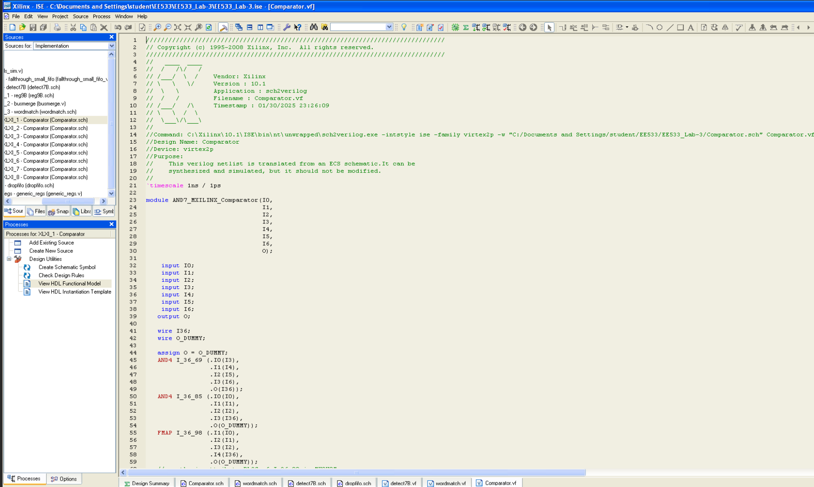

* + 1. Wordmatch generated Verilog:

* + 1. Dropfifo generated Verilog:

* + 1. Reg9B:

GitHub commits & history:  
